Unit #: 1
Unit Name: Problem Solving Fundamentals
Topic: Operators in C

Course objectives:
The objective(s) of this course is to make students
CObj1: Acquire knowledge on how to solve relevant and logical problems using computing machine
CObj2: Map algorithmic solutions to relevant features of C programming language constructs
CObj3: Gain knowledge about C constructs and it's associated eco-system
CObj4: Appreciate and gain knowledge about the issues with C Standards and it's respective behaviors
CObj5: Get insights about testing and debugging C Programs

Course outcomes:
At the end of the course, the student will be able to
CO1: Understand and apply algorithmic solutions to counting problems using appropriate C Constructs
CO2: Understand, analyse and apply text processing and string manipulation methods using C Arrays, Pointers and functions
CO3: Understand prioritized scheduling and implement the same using C structures
CO4: Understand and apply sorting techniques using advanced C contructs
CO5: Understand and evaluate portable programming techniques using preprocessor directives and conditional compilation of C Programs

Operator

An operator is a symbol that tells the compiler to perform specific mathematical or logical functions. Operator is a symbol used for calculations or evaluations
Classification of Operators:
Based on the number of operands.
1) Unary +, -, ++, --, size of ,&, *, 2) Binary +, -, *, /, %
3) Ternary ?:

Based on the operation on operands.
- Arithmetic Operators
+, -, *, /,%
- Increment and Decrement Operators
++, --
- Relational
==, !=, >=, >, <=, <
- Logical
&&, ||, !
- Bitwise
&, |, ^, >>, <<
- Address Operator and Dereferencing Operator
&, *
- Assignment =
- Short-hand
+=, -=, *=, /=, %=
- Misc operators
sizeof

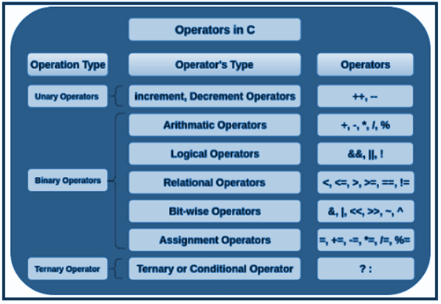
Arithmetic Operators in c
These operators are used to perform arithmetic/mathematical operation and give us results accordingly.
+ (Plus) – Give sum as a result. Example: 1+2=3
– (Minus) – Give the difference as a result. Example: -1-2=-3
* (Asterisk) – Used for multiplication and given the product as a result. Example: 2*2=4
/ (Forward slash) – Used for division and give quotient as a result. Example: 10/2 = 5
% (modulus) – Gives the remainder as a result. Example: 10 % 11 = 10; 17 %3 = 2

+ and –can also be used as unary operators –in such case, the operator is prefixed –appears to the left of the operand.
If the operands are int for /, the result is int quotient obtained truncation of the result. The operator
% is defined on integral types only.
If the operands are mixed types(int and double) in operations + -* /, the result is of type double.
There is no exponentiation operator in C.

Coding Example_1: Arithmetic operators in an expression
#include <stdio.h>
int main()
{
printf("%d%d%d%d",2+3,4-2,4*2,5/2); // 5,2,8,2
printf("%d %f %f %f\n", 25 / 4, 25.0 / 4.0, 25.0 / 4, 25 / 4.0);
// 6 6.25 6.25 6.25
// mixed mode
// 25.0 / 4 => 25.0 / (double)4.0
return 0;
}

Increment and Decrement Operators
There are two types of Increment (++) and Decrement (--) Operators.
1. Pre -increment and Pre-decrement operators: First increment or decrement the value and then use it in the expression.
2. Post -increment and post-decrement operators: First use the value in the expression and then increment or decrement.
When ++ and --are used in stand-alone expression, pre and post increment and decrement doesn't make difference.

Coding Example_1: Demonstration of pre and post increment/decrement in stand-alone expressions
#include<stdio.h>
int main()
{ int i=5;
int j=5;
print("Beginning i value is %d\n",i); //5
print("Beginning j value is %d\n",i);
++i;// i++;
printf("Later i value is %d\n",i);
j--;// --j;
printf("Later j value is %d\n",j);
return 0;
}

Coding Example_2: Code which demonstrates the usage of ++ and -- in an expression. #include<stdio.h>
int main()
{ int a=34; int b;
printf("Beginning a value is %d\n",a);// 34
b=a++; // b is 34 and a is incremented to 35
//b=++a;// First increment and then use the value in the expression
// b is 35 and a is 35
printf("b is %d and a is %d\n",b,a);
// same works for pre and post decrement operators
return 0;
}

Relational Operators
Used to check the relationship between the two operands. If the relation is true, it returns 1. If the relation is false, it returns the value 0. Relational operators are used in decision-making and loops constructs. Programming language like C which doesn’t support Boolean data type return result as 1 or 0.
Greater than (>) – Returns true (1) when the left operand value is greater than the right operand value. Example: 15 >13 is evaluated to 1.
Less than (<): Returns true(1) when the left operand value is less than the right operand value else false(0). Example: 15 <13 is evaluated to 0.
Greater than or equal to (>=): Return true(1) when the left operand value is greater than or equal to the right operand value. Example: 15 >=13 is evaluated to 1.
Less than or equal to (<=): Return true(1) when the left operand value is less than or equal to the right operand. Example: 15 <= 13 is evaluated to 0.
Equal to (==): Returns true when left operand value is equal to right operand value. Example: 5 == 5 is evaluated to 1.
Not Equal to (!=): Return true when left operand value is not equal to right operand. Example: 2 != 3 is evaluated to 0
The result of relational operation is 1 or 0. 1 stands for true and 0 for false. The relational operators should not be cascaded – not logically supported in C.
Coding Example_3: Demo of cascading of operators in C
#include<stdio.h>
int main()
{
int a=23; int b=45;
//printf("%d",5==5 && 5==5); //True results in 1
printf(“%d”, 5 == 5 == 5); // results in 0
return 0;
}
Bit-wise Operators
Used for performing bitwise operations on bit patterns or binary numerals that involve the manipulation of individual bits. Bitwise operators always evaluate both operands. Bitwise operators work on bits and perform bit-by-bit operations.
& (AND): Example: a & b
|(OR): Example: a | b
^(Exclusive OR (XOR)): Example: a ^ b
~(One’s Complement (NOT)): Example: ~a
>> (Shift Right): Example: a >> 1
<< (Shift Left): Example: a << 1

Few inputs about carrying out arithmetic opertion using bit wise operators
* multiply variable n by 2
n << 1
* check whether n is odd
n & 1
* swap two variables a and b
a = a ^ b
b = a ^ b
a = a ^ b
* check whether ith bit in variable n is 1
n & (1 << i) : 0 implies not set and non 0 implies set
* set the ith bit in n
n = n | 1 << i
* clear the ith bit in n
n = n & ~(1 << i)

Coding Example_4: // Demo of bitwise operators
int main()
{
int a=10;
int b=8;
printf(“%d”,a&b); //8
printf(“%d”,a|b); //10
printf(“%d”,a<<2); //40
printf(“%d”,a>>2); //2
printf("%d",~(10)); //-11
return 0;
}

Assignment Operators
Used to assign a new value to a variable Assignment operators can also be used for logical operations, bitwise logical operations or operations on integral operands and Boolean operands.
= Simple assignment operator: Assigns values from right side operands to left side operands. Example: C = A + B will assign the value of A + B to C
+= Add AND assignment operator: It adds the right operand to the left operand and assigns the result to the left operand.
Example: C += A is equivalent to C = C + A
-= Subtract AND assignment operator: It subtracts the right operand from the left operand and assigns the result to the left operand.
Example: C -= A is equivalent to C = C – A
*= Multiply AND assignment operator: It multiplies the right operand with the left operand and assigns the result to the left operand.
Example: C *= A is equivalent to C = C * A
/= Divide AND assignment operator: It divides the left operand with the right operand and assigns the result to the left operand.
Example: C /= A is equivalent to C = C / A

%=: Modulus AND assignment operator: It takes modulus using two operands and assigns the result to the left operand.
Example: C %= A is equivalent to C = C % A

Ternary/Conditional operator
?: Conditional Operator and it requires three operands. E1 ? E2 : E3 where E1, E2 and E3 are expressions. The expression E1 is first evaluated. If it is true, then the value of the expression is E2 else it is E3.
Coding Example_5: Demo of ?:
int main()
{
int a= 10; int b = 20;
printf("%d\n",(a>b)?a:b); //20
(a>b)? printf("%d",a):printf("%d",b); //20
printf("%d",(a>b)?a:b); //20
return 0;
}

Logical Operators
Logical Operators are operators that determine the relation between 2 or more operands and return a specific output as a result of that relation.
NOT (!) – Used to negate a Logical statement.
AND (&&) and OR (||) – Used to combine simple relational statements into more complex Expressions. In ‘C’, 0 is false and any non-zero value is true. C follows short circuit evaluation. Evaluation takes place left to right and evaluation stops as soon as the truth or falsehood of the expression is determined.

Note: Some of the operators support Sequence Point Operation.

Sequence Point Operation
How do we write safe and proper code in ‘C’ if operators have side effects and the variable values are not defined in such cases? The language ‘C’ also specifies points in the code beyond which all these effects will definitely be complete. These are called sequence points.
It defines any point in the execution of a program which guarantees or ensures that all the side effects the previous evaluation of the program’s code are done or successfully performed. It ensures that none of the alterations or side effects of the subsequent evaluations is yet to be performed at all. The term “side effects” is nothing but the changes done by any sort of function or expression where the state of something gets changed.

There are some of the basic sequence points available in C Language.
- Logical AND - &&
- Logical OR - | |
- Conditional Operator - ?:
- Comma Operator - ,
- Expression of while loop

// int a = 10;
// to support short ckt evaluation, && becomes a sequence point
// expression before &&, || will be completely evaluated.
//a++ == 10 && a == 11 // ok; will be true 1
a + a++ is undefined as the value of left a is not defined.
a++ == 10 && a == 11 will be true.
The value a++ is 10 and a becomes 11 before the evaluation moves across the sequence point &&.

Coding Example_6: //
#include<stdio.h>
int main()
{
int a = 11;
printf("%d",a++==12 | | a==12); // 1
printf("\n%d",a); // 12
return 0;
}

Expression in C
An expression in C is a combination of operands and operators. Expressions compute a single value stored in a variable. The operator denotes the action or operation to be performed. The operands are the items to which we apply the operation.
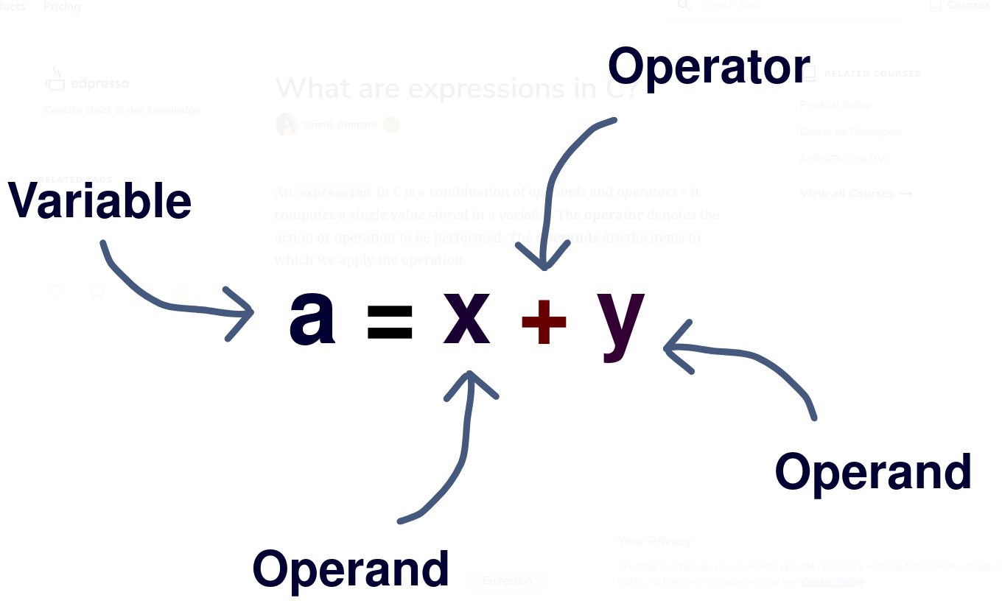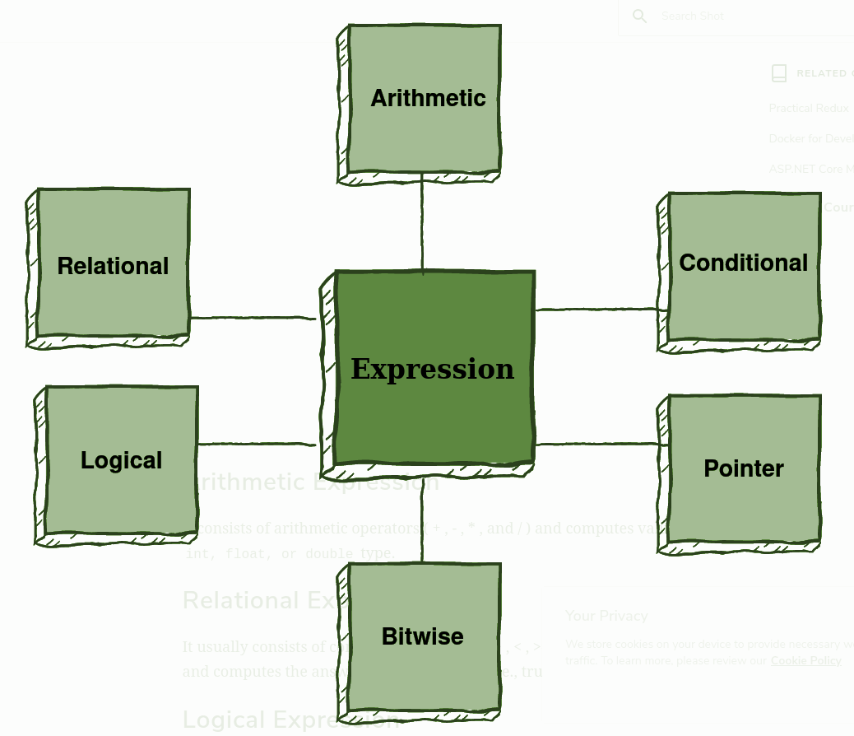
An expression can be defined depending on the position and number of its operator and operands.
Infix Expression: Operator is used between the operands
a = x + y
Postfix Expression: Operator is used after the operands
xy+
Prefix Expression: Operator is used before the operands
+xy
Unary Expression: One operator and one operand
++x
Binary Expression: One operator and two operands
x+y
Arithmetic Expression: It consists of arithmetic operators ( + , - , * , and / ) and computes values of int, float, or double type.

Relational Expression: It consists of comparison operators (> , < , >= , <= , === , and !== ) and computes the answer in true (1) or false (0)
Logical Expression: It consists of logical operators (&&, ||, and !) and combines relational expressions to compute answers in true (1) or false (0)

Conditional Expression: It consists of conditional statements that return true(1) if the condition is met and else false(0)

Pointer Expression: It consists of an ampersand (&) operator and returns address values.

Bitwise Expression: It consists of bitwise operators ( >>, <<, ~, &, |, and ^ ) and performs operations at the bit level.

Evaluation of an expression involves two parts:
- Evaluation of operands:
This is fetching the operands from the memory of the computer to the registers of the CPU. All the evaluations happen within the CPU. This order is not defined. The idea is to allow the compiler to optimize fetching of the operands. The compiler may generate code such a way that if an operand is used more than once, it may get fetched only once.

- Evaluation of operators:
This follows the rules of precedence and if more than one operator has the same level of precedence, follows the rules of association.
Table of operator Precedence and Associativity is shown below and Link for reference: http://web.cse.ohio-state.edu/~babic.1/COperatorPrecedenceTable.pdf

Does the first rule have any effect on our programs? Yes. If affects our programs if the expressions we use are not pure and have side effects.
All assignments have side effects.
Let us consider an example.
a = 10;
b = a * a++;
The value of a++ is the old value of a and therefore 10. What is the value of the leftmost a? Is the value evaluated before incrementing or after incrementing? It depends on the compiler andthe compiler options. So value of leftmost a is undefined. So, value of b is undefined.
// 10 * 10 => 100
// 11 * 10 => 110
//undefined; depends on the order of evaluation of operands
// bad code
